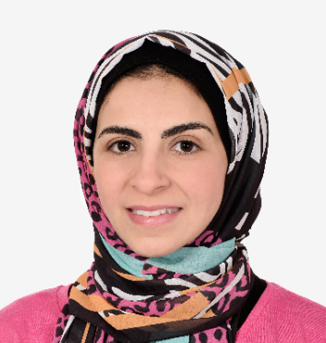  CONTACT INFORMATION  Address: Dubai Land, UAE  Mobile: +971 501559422  Email: elnajjarsoha1@gmail.com | SOHA ELNAJJAR  PHARMACIST
 | Licensed Pharmacist (DHA) with over 13 years of experience in community pharmacies, quarantine services, and healthcare insurance approvals. Passionate about delivering patient-cantered care with a creative and service-oriented approach. Committed to building trust through clear communication, compassionate service, and ethical practice. Proven ability to adapt in diverse healthcare settings, ensuring accurate medication dispensing, regulatory compliance, and seamless insurance coordination. Driven by the goal of enhancing health outcomes by focusing on people, not just products.
LICESNING & CERTIFICATION
- DHA license.
- Bachelor of Pharmacy (2010).
- Prometric Verified CBT.
PROFESSIONAL EXPERIENCE
- Senior Expert Pharmacist (Private Sector)
El Ezaby Pharmacies | Sheikh Zayed City, Giza, EG
2022-2025
- Supervised daily pharmacy operations.
- Handled customer complaints and resolved issues.
- Led and trained pharmacy staff to improve team performance.
- Managed inventory including medication stock control orders and expiry monitoring.
- Coordinating with suppliers to ensure timely deliveries and maintain optimal inventory levels.
- Managed prescription dispensing, insurance claims, and patient counselling in a high-traffic pharmacy.
- Achieved top sales performance through consultative sales and effective OTC product recommendations.
- Senior Pharmacist (Government Sector)
Sphinx Airport Clinic | 6th October, Giza, EG
2018-2024
- Dispensed medications efficiently for emergency cases.
- Performing monthly and annual inventory audits to prevent shortages or expired medications.
- Managed pharmacy stock, including ordering medications and medical supplies based on demand.
- Safeguarded public health by implementing quarantine regulations, isolating individuals, conducting health screenings, and reporting cases to prevent the spread of infections.
- Deputy Director (Government Sector)
Sphinx Airport Quarantine Clinic | 6th October, Giza, EG
2021-2022
- Supervise quarantine staff, including medical teams and inspectors.
- Conduct training on updated health measures and emergency response.
- Managed individual isolation, Health screening, Vaccination and Testing requirements, and Quality control.
- Led quarantine pharmaceutical operations, ensuring compliance with infection control and travel health protocols.
- Pharmacist (Government Sector)
Future Clinic | 6th October, Giza, EG
2015-2018
- Handled quarantine procedures, health screenings, Stock reconciliation and emergency medication dispensing to protect public health.
- Pharmacist (Private Sector)
Yudawi Pharmacies | Sheikh Zayed City, Giza, EG
2016-2018
- Managed prescriptions, insurance approvals, and patient counselling in a busy pharmacy setting, with a focus on OTC sales.
- Pharmacist (Government Sector)
Mubarak Youth Clinic | 6th October, Giza, EG
2012-2015
- Health screenings, and emergency medication dispensing, an average of 100 prescriptions per day.
EDUCATION
Bachelor of Pharmacy
Tanta University, Egypt – 2010
SKILLS
- Medical Skills:
- Insurance Claims.
- DHA Compliance.
- Prescription Verification.
- Revenue Growth Strategies.
- Drug inventory Management.
- Personal Skills:
- Leadership and Team Supervision.
- Multitasking and Patient Empathy.
- Consultative, Cross and Up Selling.
- Professional Ethics and Confidentiality.
- Patient Communication and Counselling.
- Continuous Learning and Self-Motivation.
- Adaptability in Multicultural work environments.
- Computer Skills:
- SAP & Portals.
- Microsoft Office (Excel, Word, PowerPoint).
- Insurance Different Platforms (NextCare, AXA. Yudawy, Midright, ICare, Helpat).
LANGUAGES
- Arabic: Native.
- English: Excellent.
REFERNCES
Available upon request.

