CURRICULAM VITAE
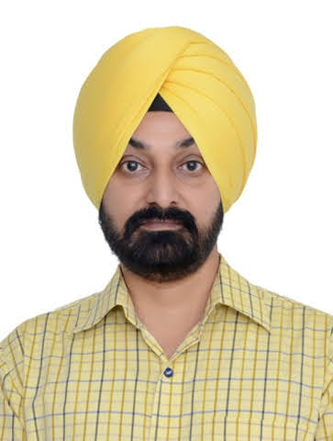
Gurwinder Singh Gill

Male
Indian
11th November, 1977

Mobile No. : 9872834508
Email ID : gillgurwinder@gmail.com

CONTACT ADDRESS

Permanent Address
House No. 311
Opp PWD Rest House
Near Railway Chowk
Sangrur (Punjab) 148001
9872834508
gillgurwinder@gmail.com

CAREER OBJECTIVE

I want to succeed in an environment of growth and excellence and earn a job which provides me job satisfaction and self development and help me achieve personal as well as organizational goals.

AREA OF INTEREST

- Medical Transcription.
- Medical Scribing.
- Medical Coding.

EDUCATIONAL QUALIFICATION

COUSE | INSTITUTION | UNIVERSITY/BOARD | YEAR OF PASSING | AGGREGATE (%)/C.G.P.A.
Intermediate (10 + 2) | National Open School | NOS | 1996 | 49
High School  ( 10th) | Adarsh Model School Sangrur | P.S.E.B. | 1994 | 71

PROJECT WORK

- Worked as Medical Scribe from May 29, 2023 to October 3, 2024 at Cognizant Technology Solutions India Pvt. Ltd.
- Worked as QC (Medical Transcription) from October 1 2013 to May 25, 2023 at DeliverHealth Solutions India Pvt. Ltd.
- Worked as QA (Medical Transcription) from March 21, 2007 to September 10, 2013 at AM Cyber Solutions Mohali India.
- Worked as Medical Transcriptionist from March 12, 2001 to March 20, 2007 at ISA Softtech Solutions Pvt. Ltd. Mohali
- Worked as Medical Transcriptionist from September 4, 2000 to March 11, 2001 at IDS Infotech India Ltd.

TRAINING

- Certified Professinal Coder training from AAPC and cleared CPC in May 2025.
- Completed 6 months of Medical Coding Internship at Clin Biosciences, Chennai.
- Medical Transcription Training at IDS Infotech India Ltd.

STRENGTHS

- Self-confidence
- Highly Ambitious
- Punctuality
- Positive attitude
- My Family

DECLARATION

I hereby state that all the above information is true to best of my knowledge.

PLACE : SANGRUR Gurwinder Singh Gill

