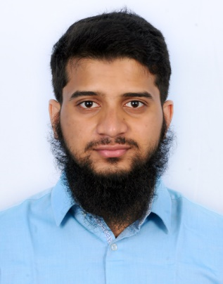
Dr. Mohamed Sohail Shareef, BDS

Medical Scribe | Dental Surgeon
Phone: +971583060024
Email: sohailshareef16@gmail.com

Professional Summary
Detail-oriented medical scribe and dental surgeon with over two years of combined clinical and non-clinical healthcare experience. Committed to providing exceptional patient care and achieving excellence in dental services. Proficient in documenting medical records, facilitating physician-patient communication, and supporting clinical operations with a strong understanding of medical terminology and healthcare workflows. Passionate about delivering accurate documentation and improving the efficiency of healthcare services.

Core Skills
- Medical Documentation and Transcription
- Electronic Health Records (EHR) Management
- HIPAA Compliance
- Medical Terminology Proficiency
- Physician-Patient Communication
- Clinical Workflow Optimization
- Clinical Procedures

Work Experience
Medical Scribe
IKS Healthcare
August 2022 – December 2023
- Accurately documented physician-patient interactions in real-time, including medical histories, diagnoses, treatment plans, and follow-ups.
- Managed electronic health records (EHR) efficiently, ensuring compliance with HIPAA standards.
- Supported physicians in clinical decision-making by streamlining administrative processes and enhancing workflow efficiency.
- Maintained a high level of accuracy in medical reports, improving patient care delivery.
Quality Analyst
Onpoint healthcare partners
September 2024 - January 2025
-Maintained accuracy of the chart notes and reviewed the notes including proof reading, accurate medical information to ensure the highest quality note is delivered.

General Dentist
Wisdom Dental Clinic, Coimbatore
January 2022 – December 2023
- Performed clinical procedures including RCT, extractions, restorations, and prosthetic rehabilitation.
- Managed patient records with attention to detail, contributing to accurate case documentation.
Trichy Government Hospital
Senior internship
February 2024 – July 2024
- Performed clinical procedures, including root canal treatment (RCT), extractions (including impactions), restorations, oral prophylaxis

Education
Bachelor of Dental Surgery (BDS)
Sri Ramakrishna Dental College and Hospital, Coimbatore
October 2016 – May 2022

Languages
- English: Expert
- Hindi/Urdu: Native Proficiency
- Tamil: Fluent
- Arabic: Beginner

Technical Proficiency
- EHR Platforms (experienced with Epic)
- Microsoft Office Suite (Word, Excel, PowerPoint)
- Medical Transcription Tools

Personal Information
Date of Birth: 16 June 1998
Location: Dubai, UAE (on visit visa)

